Meta Film Doc presents
#MeToo-mosaic
A mosaic of #MeToo experiences
told by 100 Danish actresses and actors
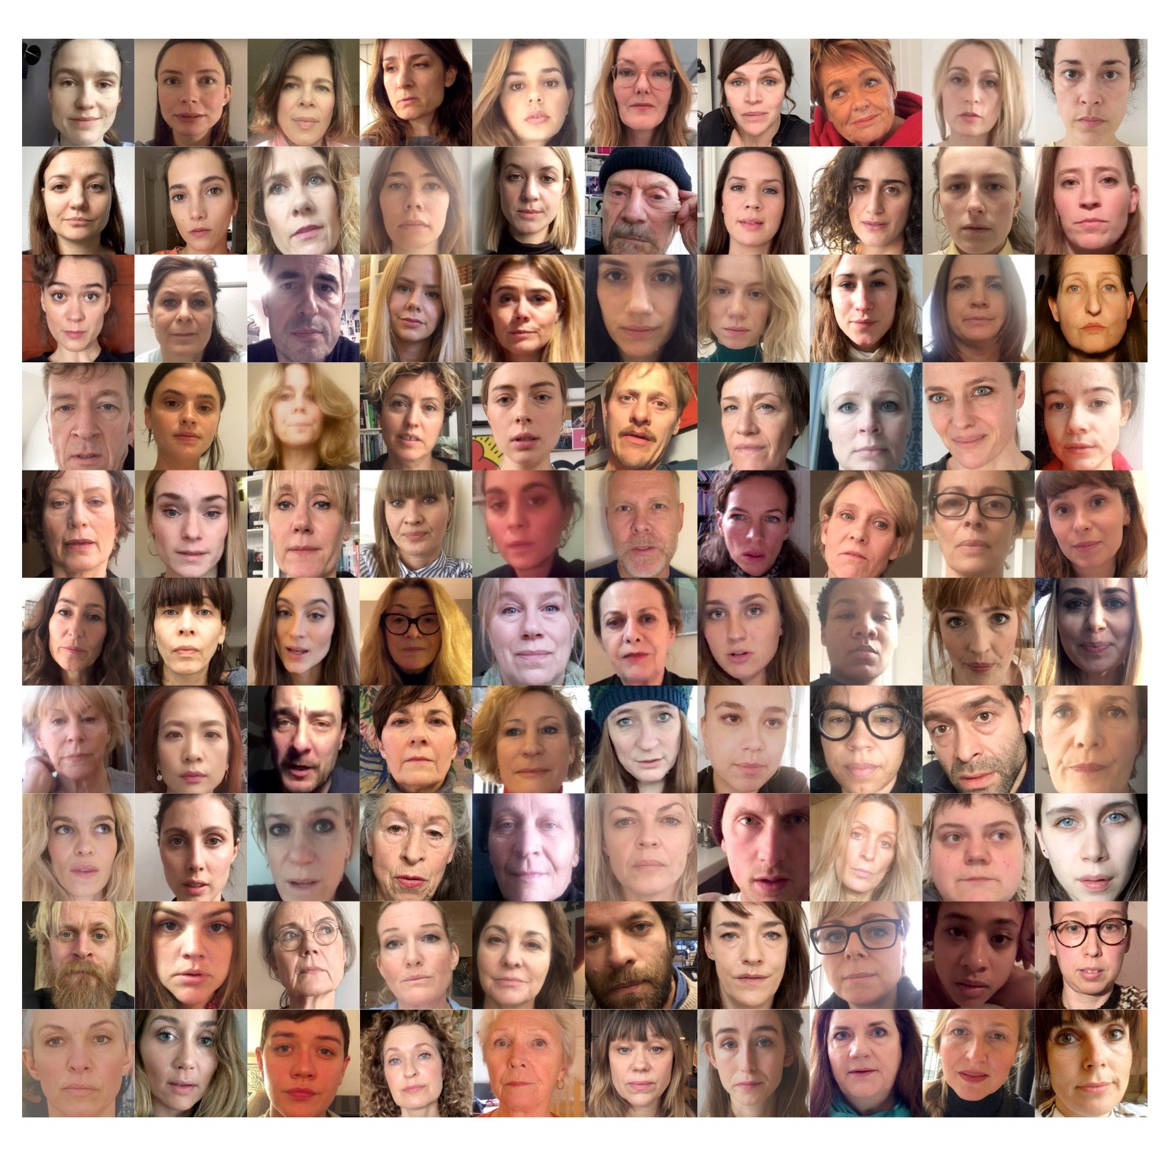
9th April 2018, The production company Meta Film in Copenhagen launched the website dkmetoo.dk – containing a #MeToo mosaic with 100 videos, educational material bringing #MeToo into Danish classrooms and much more.

This week the Danish #MeToo mosaic travels to Cannes Film Festival and will be screened Wednesday 9th May and 11th May at the Scandinavian Terrace - 55 La Croisette, Cannes.

From Wednesday 9th May the #MeToo mosaic will also be available with English subtitles on dkmetoo.dk.

The #MeToo mosaic is produced by Mette Bjerregaard and Meta Louise Foldager Sørensen, Meta Film Doc.

Contact: mette@metafilm.dk / +45 40 86 50 95

INTRODUCTION
The #MeToo-movement was brought into the spotlight by the shocking revelations of sexual harassment and power abuse in the film industry.
Meta Film has produced a #MeToo mosaic, engaging 100 talented Danish actresses and actors to pass on the #MeToo torch to the entire Danish society.
The #MeToo mosaic illustrates how sexism and sexual abuse are problems ingrained in the very fabric of society – and not solely related to the film industry.
100 actresses and actors interpret #MeToo experiences from 100 Danes. The individual stories are very different to each other and come from people of all walks of life – the parking warden, a professor, a cleaner, a young sports talent, a psychologist, an asylum seeker and stories from many other industries as well as personal stories from the private sphere.

ABOUT THE PROJCET
Our objective with the #MeToo mosaic is to extend the debate from the film industry into the broader society.
The #MeToo movement gained momentum with the Harvey Weinstein case. Therefore there has been a lot of attention on the stakeholders of the film industry. But #MeToo is not merely about this. It’s much more. It’s about society as a whole. About an inherently sexist culture. This is what we try to illustrate with the #MeToo mosaic.

The mosaic serves the purpose of explaining that these stories are not simply individual cases. They are part of a vast pattern. A problem for the entire society. It is part of our culture. It has been considered a natural circumstance, something very ordinary. Do we really want our culture to be this way?

The development of Danish culture has been underway for more than a millennium, but women’s rights have only been on the agenda for the past 100 years. In this light, it’s not strange, that we still have some way to go in terms of gender equality.

We’re not placing the guilt on anyone for this. Men are not collectively the perpetrators. Women are not collectively the victims. It is simply a depiction of a culture we’re all part of.

To put it briefly, our wish for the #MeToo mosaic is to draw a picture of the sexism of our society and shed light upon the inequality between the genders.

With the hope that we can all agree that it is not a desirable culture.
With the hope that we can all change for the better. All of us.

WHAT IS A #METOO STORY?
A #MeToo experience is defined as a sexist or sexual violation in a physically, mentally or hierarchically unequal power structure. Whether it happens at work, at home, at the sport’s club, on public transport or somewhere else, and to what degree the abuse of power unfolds is essentially irrelevant. All of the stories play their part in shining a light on particular underlying social structures and a social issue.

APPROACH TO THE PROJECT
Our starting point was to focus on both women and men who have experienced – or on same occasions, observed – a sexual violation in an uneven power structure. During our gathering of the stories, it became clear the vast majority of instances were women violated by men. However, there are cases where a man is violated by another man or woman, or where a woman violates another woman. Examples of these situations can also be found in the mosaic.
Sexual violation is a taboo for both women and men, unreported instances, different definitions and perceptions of sexual harassment also make it impossible to produce an unambiguous picture of reality, for instance, determining how many women versus men are subjected to sexual violations. Therefore, the amount of the various types of situations in the mosaic are not meant to serve the purpose of illustrating a statistical circumstance. But we can conclude that the majority of the cases and the #MeToo stories, we have had access to, come from women, and therefore, the mosaic illustrates a general disparity between the genders.
Anonymous accounts about sexual harassment have been collected through 10 Danish trade unions, from the book Sexual harassment at work by Anette Borchorst & Lise Rolandsen Augustin, Ålborg University. Furthermore, #MeToo stories have been collected through LOKK (National organisation of women’s shelters in Denmark), Women´s shelter Danner, the organisations The Everyday Sexism Project and The Danish Women´s Society as well as through an open call.
The #MeToo experiences are anonymous. No names or specific work places are mentioned. The stories have been cut to the bone, while in some cases, it has been necessary to change the language from written to spoken. The actors have all each interpreted their specific text, which means that in some cases, a few words have been changed. The crucial point is that the meaning of the story hasn’t changed. The stories from the trade unions are all closed cases from courts in Denmark, where the claim was sustained. These cases have been received as dossiers, which is why it has been necessary to display the cases as personal stories. Once again, nothing has been changed in connection to the meaning or consequences of the case.

WHAT DID WE LEARN?

We learned the following from collecting the stories:
- Many have told us, they had a long series of #MeToo - experiences.
- Most abuse happens early in life, and it becomes less frequent by time
- The reaction to abuse is normally shame and guilt. Some never share their story.
- Many women will consider harassment a normal part of her life, and do not necessarily find their experiences noteworthy
- Far more women than men experience sexual harassment.
- The men who had experienced sexual abuse or harassment were often LGBT or young.
- The vast majority of stories we received were female victims and male perpetrators.
- It is apparently very uncommon for women to be on the giving end of abusive relationships.
- Sexual abuse or harassment at the work place was often due to the management not taking their responsibilities seriously.

100 ACTRESSES AND ACTORS
The following 100 actresses and actors have supported the #MeToo project and told #MeToo stories from 100 Danes:
Anna Clara Sachs, Amalie Dollerup, Amalie Lindegård, Amanda Collin, Anette Støvelbæk, Ann Hjort, Anna Neye, Anne Louise Hassing, Anne Marie Helger, Anne Sofie Espersen, Anne-Grethe Bjarup Riis, Birgitte Hjort Sørensen, Birgitte Raaberg, Camilla Bendix, Camilla Søeberg, Carsten Bjørnlund, Charlotte Fich, Charlotte Munck, Christian Gade Bjerrum, Christiane Bjørg Nielsen, Claes Bang, Coco Hjardemaal, Danica Curcic, Diana Axelsen, Ditte Hansen, Ditte Ylva Olsen, Dorte Højsted, Ellen Hillingsø, Emma Sehested Høeg, Ena Spottag Fogh, Fanny Louise Bernth, Filippa Suenson, Frederikke Dahl Hansen, Ghita Nørby, Inge Sofie Skovbo, Jannie Faurschou, Jens Albinus, Jesper Christensen, Julie Agnete Vang, Julie Brochorst Andersen, Julie Christiansen, Julie Grundtvig Wester, Julie Zangenberg, Katrine Greis-Rosenthal, Kirsten Peüliche, Laura Bro, Laura Drasbæk, Laura Elisabeth Christensen, Lene Maria Christensen, Lykke Sand Michelsen, Lykke Scheuer, Maibritt Saerens, Maj-Britt Mathiesen, Maria Rich, Maria Rossing, Marianne Søndergaard, Marie Askehave, Marie Bach Hansen, Marie Hammer Boda, Marie Louise Wille, Marina Bouras, Mathilde Arcel Fock, Mathilde Norholt, Merete Mærkedahl, Mia Jexen, Mia Lyhne, Mikkel Boe Følsgaard, Morten Kirkskov, Neel Rønholt, Olivia Joof, Patricia Schumann, Rasmus Hammerich, Rosalinde Mynster, Sandra Yi Sencindiver, Sara Fanta Traore, Sara Hjort Ditlevsen, Sara Marie Maltha, Sarah Boberg, Sarah Juel Werner, Sarah-Sofie Boussnina, Sofie Lassen-Kahlke, Sofie Pallesen, Sofie Stougaard, Solbjørg Højfeldt, Stephania Potalivo, Stine Stengade, Susanne Storm, Tammi Øst, Therese Damsgaard, Therese Glahn, Thomas Levin, Thure Lindhardt, Tina Gylling Mortensen, Tove Bornhøft, Trine Pallesen, Ulla Henningsen, Vibeke Hastrup, Vicki Berlin Tarp, Victoria Carmen Sonne og Özlem Saglanmak.

BIOS
Mette Bjerregaard is a film producer with an educational background in Communication and Psychology. She produced the international media initiative WHY WOMEN? starring Helen Mirren, focusing on girl’s and women’s rights and health. Mette will in the future produce films at Meta Film Doc, a brand new documentary film department, spun out of Meta Film, while also launching fiction and documentary projects.

Meta Louise Foldager Sørensen is a film producer, founder and the CEO of Meta Film and SAM Productions. Meta has a distinguished career in Danish film and tv production. Her films have won numerous awards, domestically and abroad. She has had the pleasure of working with Lars von Trier, Nikolaj Arcel, Pernille Fischer Christensen, Omar Shargawi, Morten Hartz Kaplers, Heidi Maria Faisst, Mikkel Munch-Fals, Samanou Sahlstrøm, Kasper Barfoed, Fenar Ahmad and Per Fly.

ABOUT META FILM DOC
Meta Film Doc is a new division under Meta Film, focusing on thought-provoking and innovative documentaries. It is the ambition of Meta Film Doc to become an important production house in the international documentary sphere though groundbreaking original concepts

PERSONAL MOTIVATION BEHIND THE PROJECT
by Meta Louise Foldager Sørensen
I’ve personally moved from thinking #MeToo was a movement about first world problems to my current view, that it’s one of the most important things to happen in our culture for many years. I would like to share this process I have been through, where I suddenly saw a completely different picture.
I have had a number of #MeToo experiences in my life. I didn’t think they constituted a problem. I considered them to be normal circumstances, which women had to accept somehow.
It became evident to me, that if my level of #MeToo experiences was ‘normal’, then other women would have similar amount. And then I realized, all the stories had a pattern. There was an underlying culture, which was facilitating this. A culture where sexism, sexual harassment and sexual abuse was “normal” for women, and that shouldn’t be acceptable.
The development of Danish culture has been underway for more than a millennium, but women’s rights have only been on the agenda for the past 100 years. In this light, it’s not strange, that we still have some way to go in terms of gender equality.

We’re not placing the guilt on anyone for this. Men are not collectively the perpetrators. Women are not collectively the victims. It is simply a depiction of a culture we’re all part of.

I think the #MeToo movement can change a lot of things for women around the world. And with social media, women across the world can inspire each other by writing #MeToo and #TimesUp. And things could get very interesting. I want to support and take part in a movement like that.
As an executive in this business, I consider it my duty, to push for a change of this culture. I’d like to appeal to every leader, executive, board member and so on, to take a clear position. 0% tolerance for sexist remarks and behavior at the work place.
The unions have fought this war on sexual harassment for a long time. I think it means a lot for the cause, when celebrities like Angelina Jolie and others say #MeToo and things really catch on and people are inspired.
An actor makes a living from adopting other peoples stories and reinterpreting them. Therefore it was a natural solution to ask 100 actresses and actors to tell these stories from 100 Danes.
We hope the mosaic will push the debate out to the rest of society. We hope people will se the big picture. We hope skeptics can lose their preconceived notions.
We hope many will see these films. And understand the big picture. We are proud that the films will reach 90% of all schools in Denmark, because it’s the future generations that will ultimately forge the relations between the genders.

